**Sales Analysis Report**

**Sales**

Out of Total Sales for the year 2019 to 2022, Technology had high sales of 2327k and Office Supplies had low sales. Category Technology had a high amount of sales in 2019,but in 2020 furniture had high sales. In 2021 and 2022 Technology had high sales.

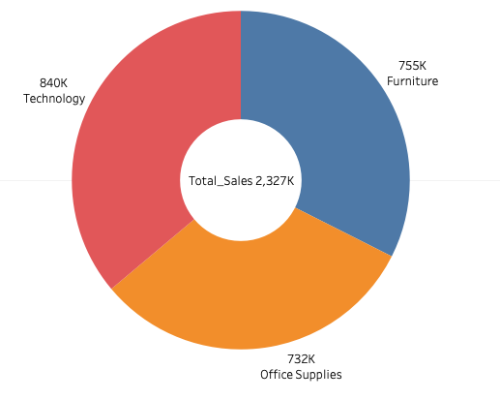

**To achieve the target**

Technology needs to achieve 19% of sales to reach Target sales and Furniture needs 32% and Office Supplies has another 37% to reach Target Sales

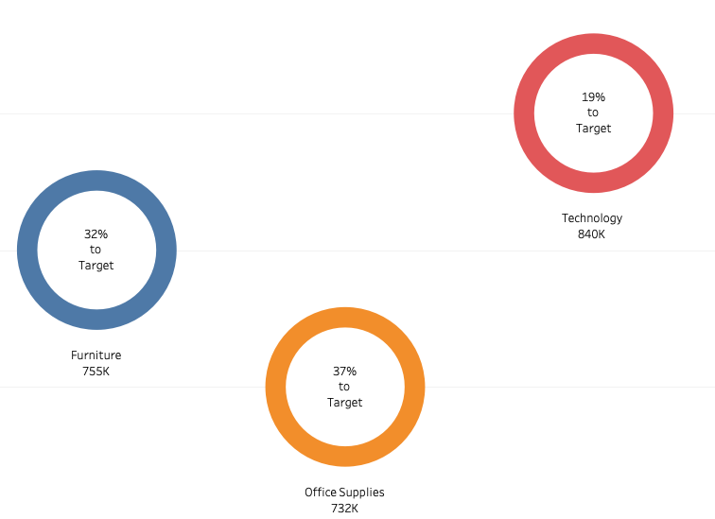

**Profit**

In Sub Category,Copiers had highest profit of 19% and Tables suffered a huge loss of 6%

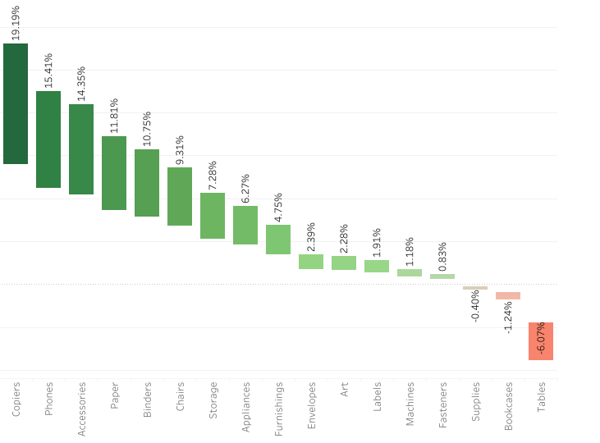

*The West Region had high sales and the South Region had low sales. Most Customers prefer Standard Class*

